**Lesson 4 Demo 9**

**Understanding Pod Topology Spread**



Steps to be followed:

1. Adding Topology Spread entries to the pod configuration

**Step 1: Adding Topology Spread entries to the pod configuration**

1. Navigate to deployments folder:

***cd deployments***

1. Open singlepod.yaml:

***vi singlepod.yaml***

1. Add the below code to the yaml file:

***apiVersion: v1***

***kind: Pod***

***metadata:***

***name: webserver***

***namespace: test***

***labels:***

***app: nginx***

***tier: front***

***version: v1***

***env: production***

***spec:***

***containers:***

***- name: nginx***

***image: nginx***

***replicas: 0***

***ports:***

***- containerPort: 80***

***topologySpreadConstraints:***

***- maxSkew: 1***

***topologyKey: Zone***

***whenUnsatisfiable: DonNotSchedule***

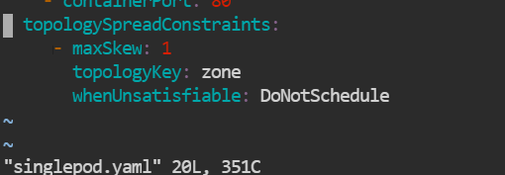

1. Execute the following command to check the deployment status:

***kubectl get pods -n test***

